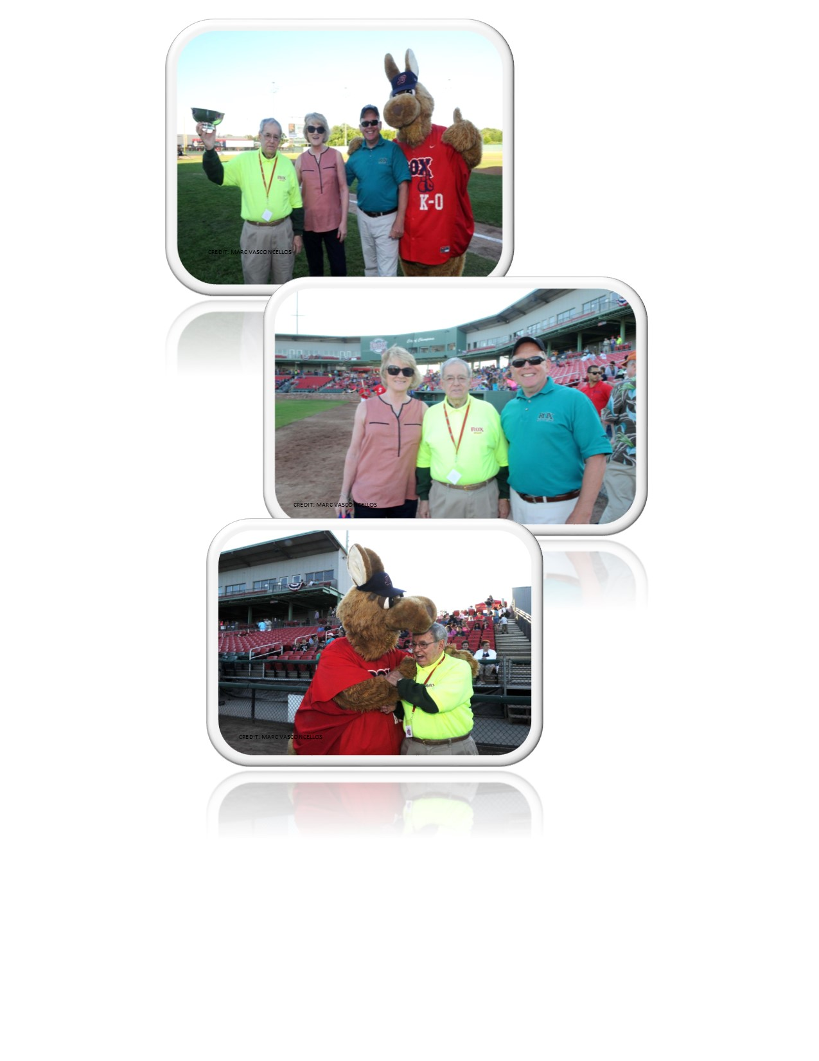
Celebrate Volunteerism in the Brockton Public Schools

Robert “Bobby “Bonnette, 2016 Albert N Baroncelli Award Recipient

The Albert N. Baroncelli Award

The Albert N. Baroncelli Award is given each year to a community member or group who has volunteered their time and efforts to enhancing the educational opportunities afforded to Brockton students. The Award is named for former School committee member Albert Baroncelli, a driving force behind the creation of Community Schools. Mr. Baroncelli championed before and after school activities and stressed the importance of using the schools as community centers, where parents, children and residents could learn new skills, crafts and participate in recreational sports.

Each year the Brockton Community Schools honors an outstanding community member or group whose volunteer efforts have made an impact on the lives of Brockton students and community members. Please help us by nominating a community member or group whose volunteer efforts have made a difference in the City of Champions.

The criteria for this award is as follows:

- The recipient should be any community member or group who has made a significant contribution to the Brockton Public Schools through volunteerism.
- The community member or group should have been involved in a Brockton Public School program or another school program for at least 2 years.
- Any member of the Brockton Community can make a nomination for the award (i.e. principal, teacher, parent, community member, organization, or other BPS staff member)
- The recommendation should highlight the service performed by the nominated community member or group.
The Executive Committee shall make the recommendation to the Community Schools Advisory Board from all the submitted nominees

Albert N Baroncelli Award Nomination 2018

Nominees Name_____________________________________________________

Nominees phone number______________________________________________

Your Name__________________________________________________________

Your Phone Number__________________________________________________

Please submit a brief description about the nominee and return your entry no later than :
Friday, May 4, 2018
To
Brockton Community Schools
43 Crescent St Brockton MA 02301
508-580-7595
www.brocktoncommunityschools.com

